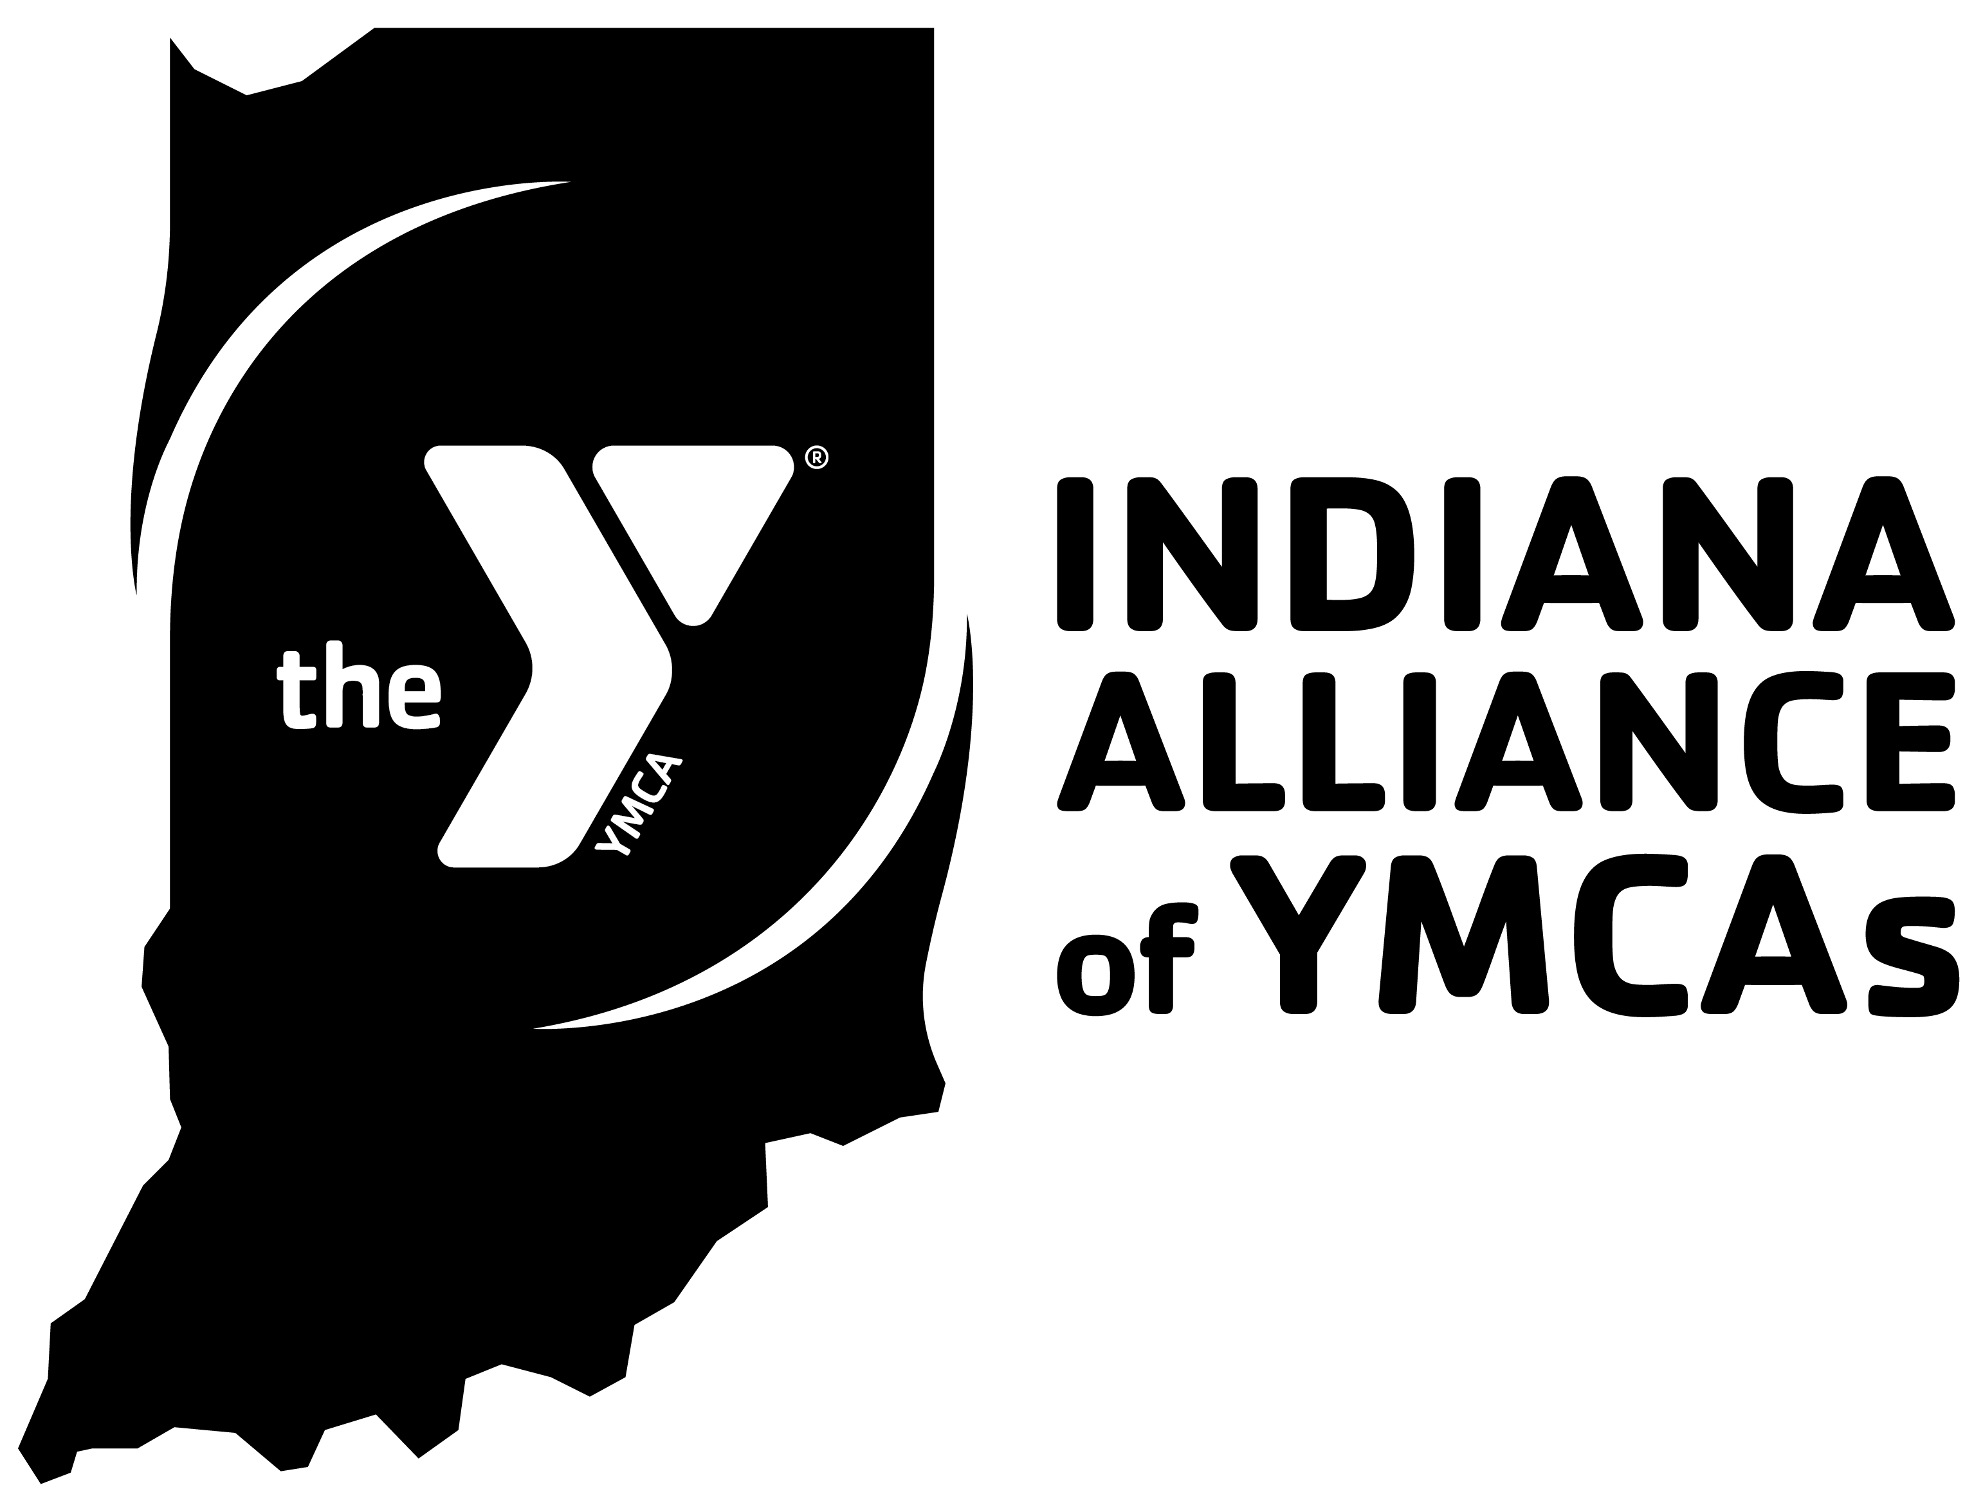

2023 Staff Assembly
Staff Award Selection Form - Rising Star

This is your opportunity to recognize program staff for outstanding contributions made to your association. YMCAs may select one awardee per branch to be recognized as a Rising Star. Please submit selections (including a jpeg photo)_by March 31, 2023, and register your Rising Star(s) to attend the 2023 Program Rally by April 19, 2023.

YMCA Name: Click or tap here to enter text.

CEO submitting nomination: Click or tap here to enter text.

Selection criteria:
- Individual has been employed by the Y no more than three years, full- or part-time
- No performance concerns
- Demonstrates passion, drive, and determination
- Demonstrates leadership competencies and exhibits behavior/performance that indicates they will have a successful and lengthy Y career.

Name:
Title:
Some examples of this person’s accomplishments are:

Please return completed nomination forms to melissa@indianaymcas.org.

*Due to time required to order awards, we must have selections submitted by March 31, 2023. No exceptions.

