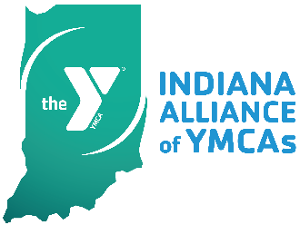

Indiana Alliance of YMCAs
Annual (virtual) Executive Conference
May 6-7, 10 am to 2 pm daily

ENERGIZE. EVOLVE. EMERGE.

Thursday, May 6, 2021

10:00 am Welcome/Keynote

11:00 am Open Space Sessions
Topics:
- Board development
- Financial Development
- Membership
- Human Resources

11:30 am Lunch/Visit Exhibitor Rooms

12:30 pm Breakouts – Round 1
- Anti-hunger/food programming initiatives
- County Health Data

1:20 pm Breakouts – Round 2
- Blue Zone Projects
- It’s Not Magic

2:00 pm Day ends

Friday, May 7, 2021

10:00 am Welcome/Breakouts – Round 3
- Energize Your Team: Create a Culture of Camaraderie
- Solutions for Water Safety by NAGI

10:50 am Breakouts – Round 4
- Planning for Tomorrow’s Older Adults
- Advocacy/Public Policy

11:30 am Lunch/Visit Exhibitor Rooms

12:30 pm Breakouts – Round 5
- What a Board Thinks?
- County Health Data

1:15 pm Breakouts – Round 6
- Managing Stress
- Creating for Tomorrow

1:50 pm Conference Takeaways

2:00 pm Day ends

