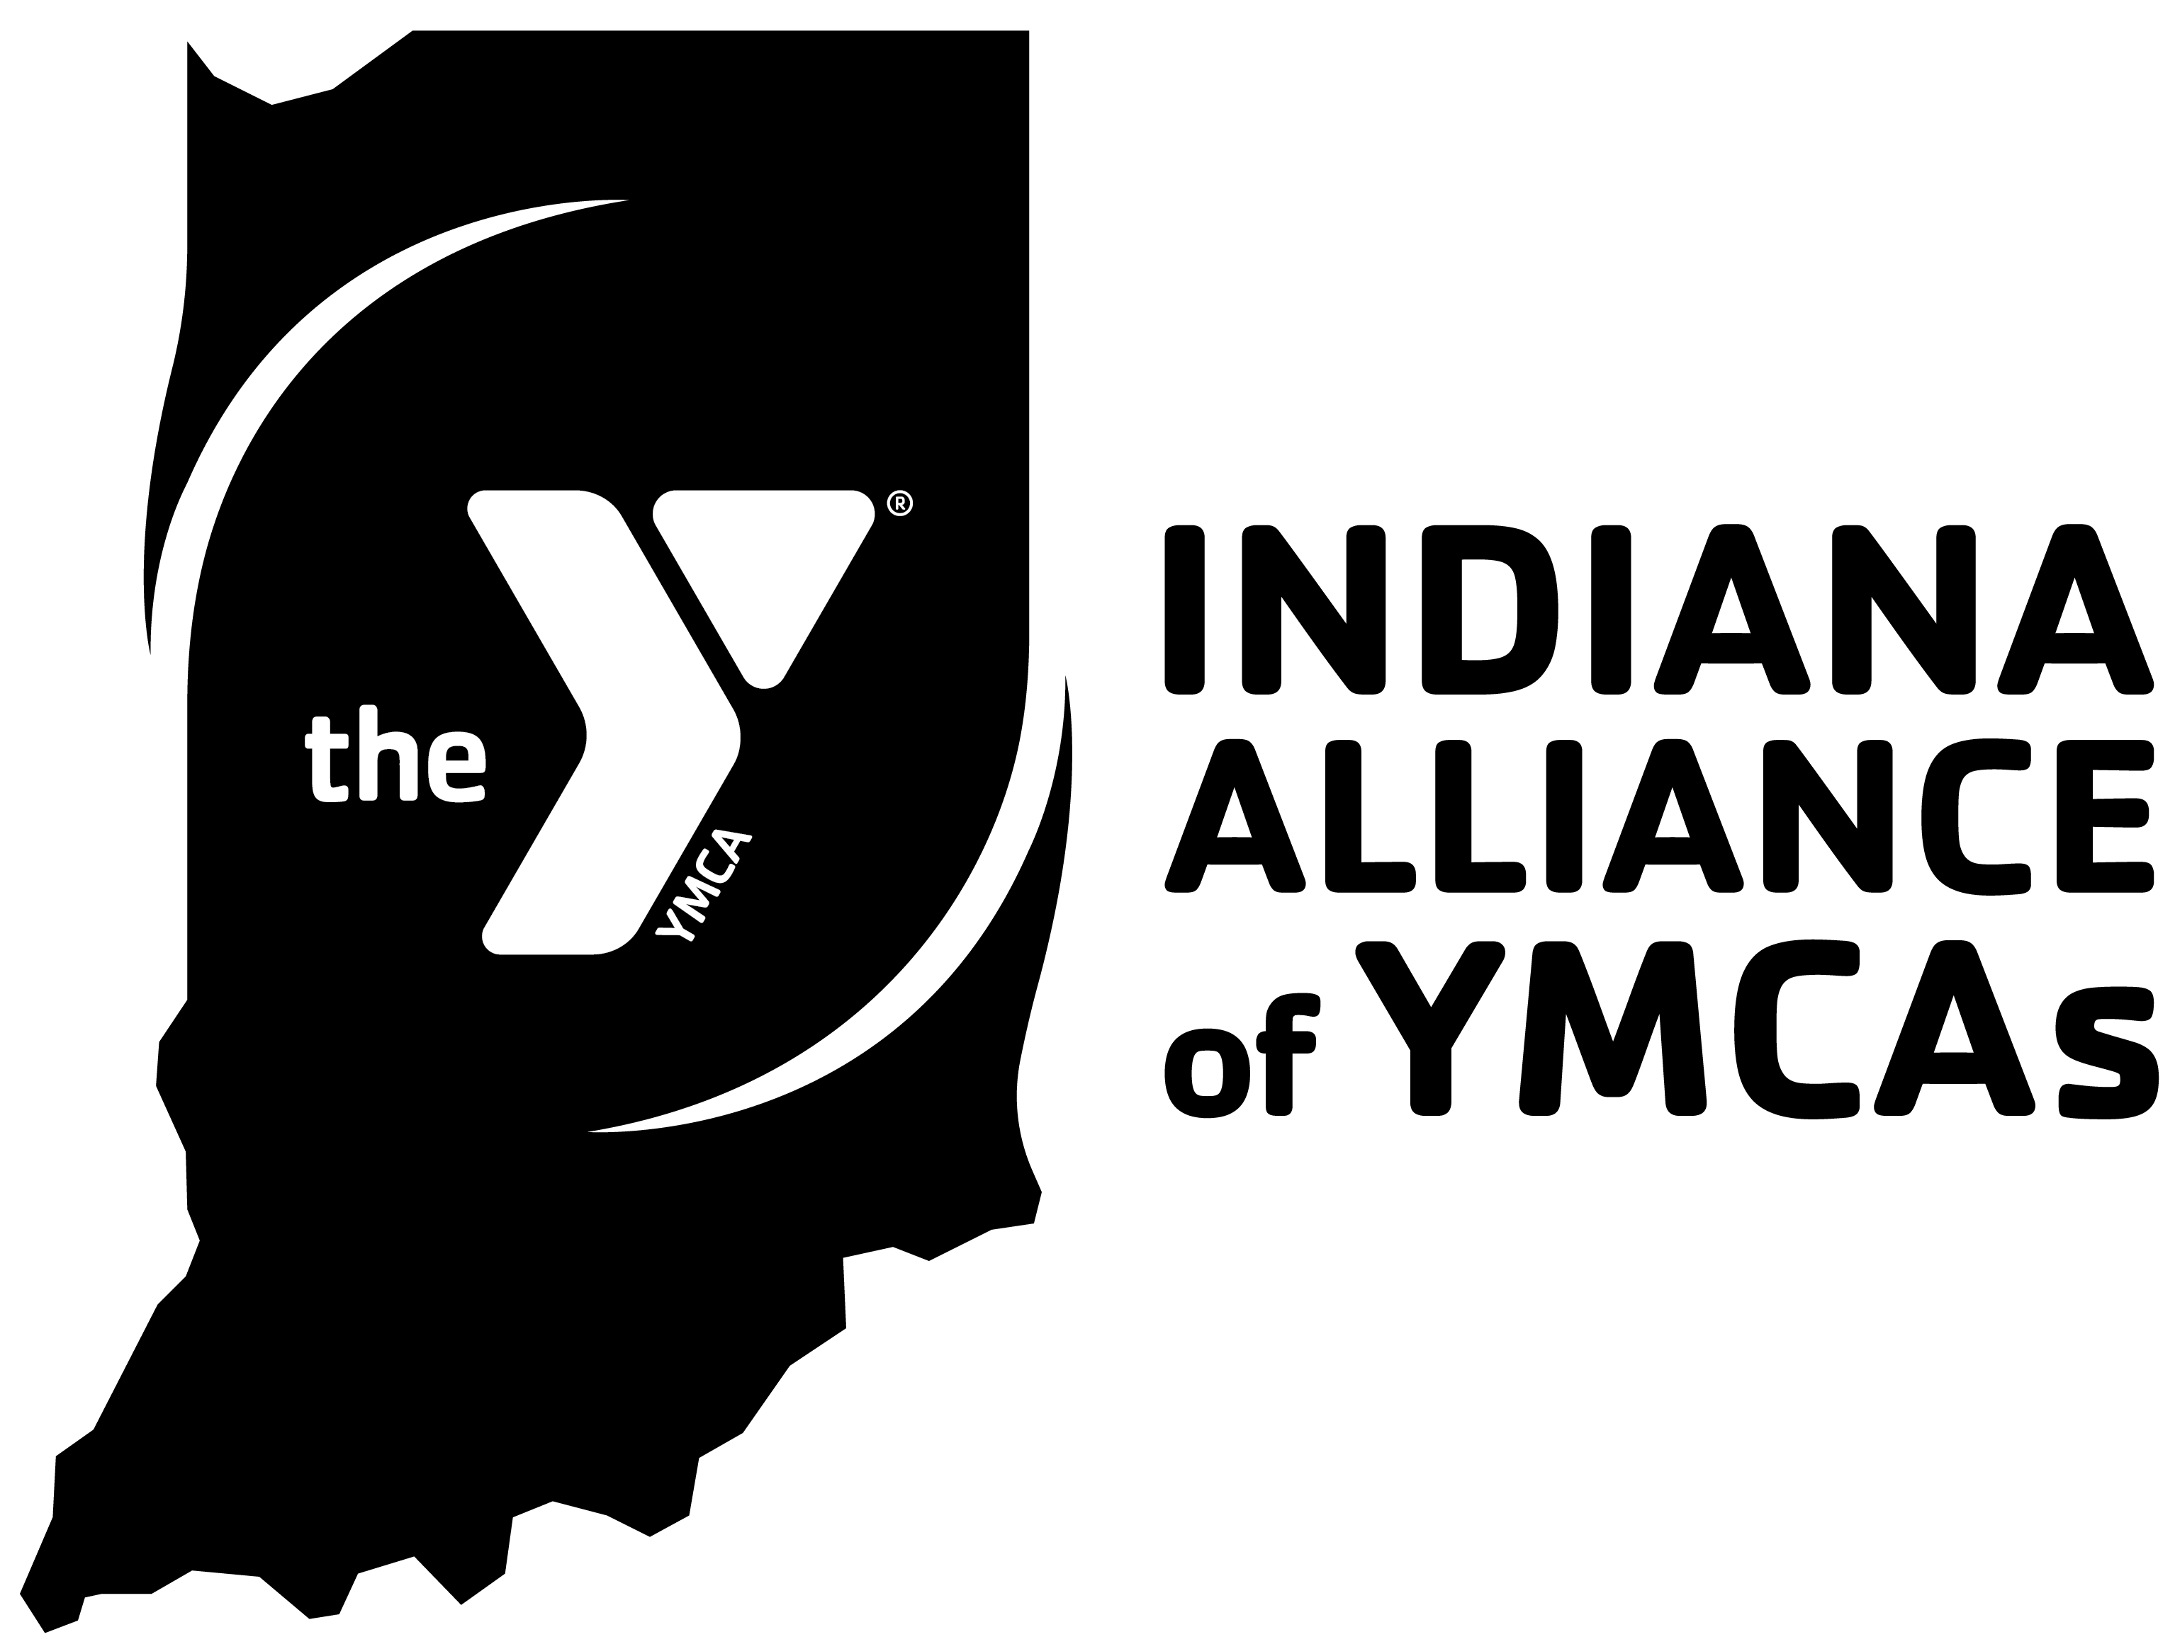

2023 Staff Assembly
Staff Award Nomination Form - Award of Excellence

This is your opportunity to recognize program staff for outstanding contributions made to your association. This is a competitive process; YMCAs may nominate one individual per association. A selection team will review the nominations and select the award recipient (up to 3 statewide) to be recognized at the Staff Assembly. YMCAs may alert individuals they were nominated, but individuals will not be notified of their selection before the event.

Please submit nominations (including a jpeg photo)_by March 31, 2023, and register your nominee to attend the 2023 Program Rally by April 19, 2023.

YMCA Name: Click or tap here to enter text.

CEO submitting nomination: Click or tap here to enter text.

Nominating criteria:
- Individual must have a minimum of 3 years of Y service.
- Individual must demonstrate consistent, outstanding, and innovative program development and management.
- This award is intended to recognize the total body of work of the individual. Please ensure the description below provides that detail or the selection committee may need to ask for more information.

Name:
Title:
Tenure:
Some examples of this person’s accomplishments are:

Please return completed nomination forms to melissa@indianaymcas.org.

*Due to time required to order awards, we must have nominations submitted by March 31, 2023. No exceptions.

