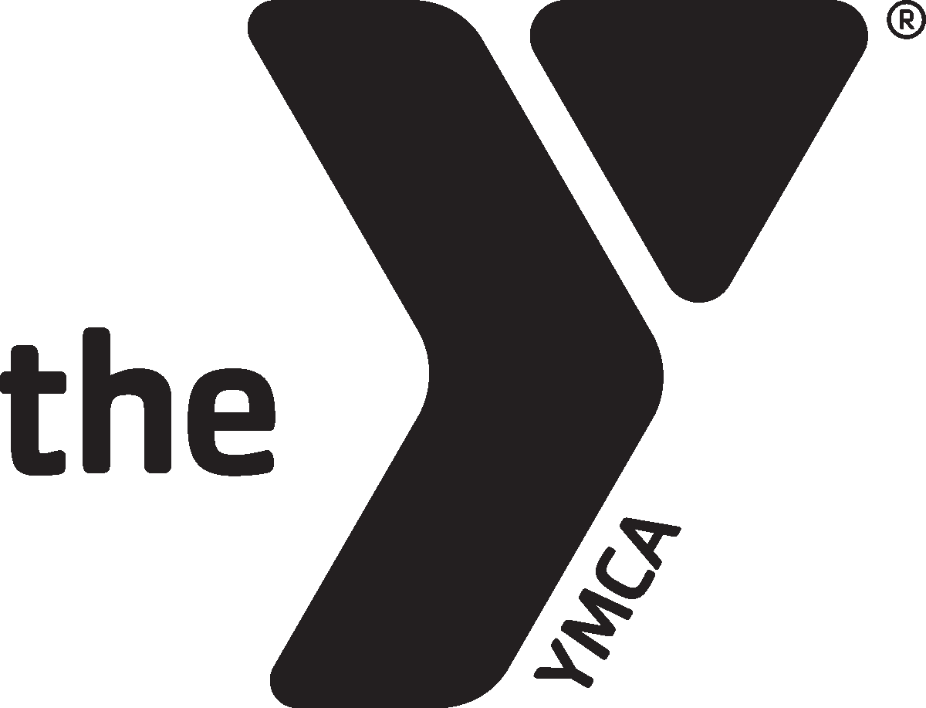

2020 CEO/CVO Meeting
March 11, 2020
The Sycamore at Mallow Run
7070 W Whiteland Road
Bargersville, IN 46106
10 am to 3 pm

Theme: Measuring Our Potential

AGENDA

9:30 am Check-In/Breakfast

10 am Welcome/Agenda review

10:15 am Session 1: Measuring the sustainability of your Y

11:30 am LUNCH

12:30 pm Session 2: Measuring the performance of your board

1:45 pm Session 3: Measuring the performance of our Alliance

2:45 pm Closing

