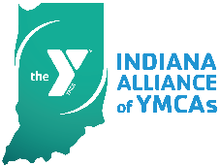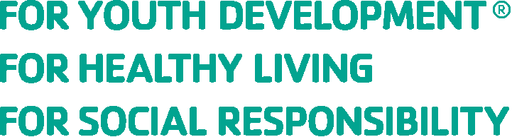

Indiana YMCA Alliance of YMCAs
2021 Sponsor/Exhibitor Agreement Form

Company: Click or tap here to enter text. Contact Name: Click or tap here to enter text.
Title: Click or tap here to enter text. Phone: Click or tap here to enter text.
Cell: Click or tap here to enter text. Fax: Click or tap here to enter text.
Email: Click or tap here to enter text. Website: Click or tap here to enter text.
Mailing Address: Click or tap here to enter text. City/State/Zip: Click or tap here to enter text.

Please indicate the opportunity you’d like to secure for the Indiana Alliance of YMCAs’ 2021 events.

Spring Alliance Meeting, May 5, 2021
Please email this form to Melissa Everhart at melissa@indianaymcas.org and forward a check separately or print and send this form with the check to the address below. Please also forward your company’s logo in .jpeg or .png format to Melissa.

Make Checks Payable to:
Indiana Alliance of YMCAs
Attn: Melissa Everhart, Project Manager
615 N Alabama St, Suite 205
Indianapolis, IN 46204

By signing below, applicant certifies he/she has read and agrees to the terms and conditions set forth herein and has the authority to sign and enter into this contract on behalf of the company set forth in the contact information above.

Our commitment totals $ Click or tap here to enter text. in support of the Indiana Alliance of YMCAs.

(Company Representative Signature)

Click or tap here to enter text.
(Title)

Virtual
☐ Spotlight Sponsor = $300

Executive Conference, May 6-7, 2021
Virtual
SOLD
☐ Exhibitor = $450
☐ Presenting Sponsor = $4000

Fall Alliance Meeting, November 3, 2021
The Sycamore at Mallow Run Winery
SOLD
☐ Lunch Sponsor = $1700

Leadership Conference, November 4, 2021
Indianapolis Marriott North
SOLD
☐ Exhibitor = $900
☐ Breakfast Sponsor = $1700
☐ Lunch Sponsor = $1700
SOLD
SOLD
☐ Dessert Sponsor = $1700
☐ Presenting Sponsor = $4000

☐ Education Sponsor = $2,500
NEW IN 2021 – look for details in sponsorship guide

