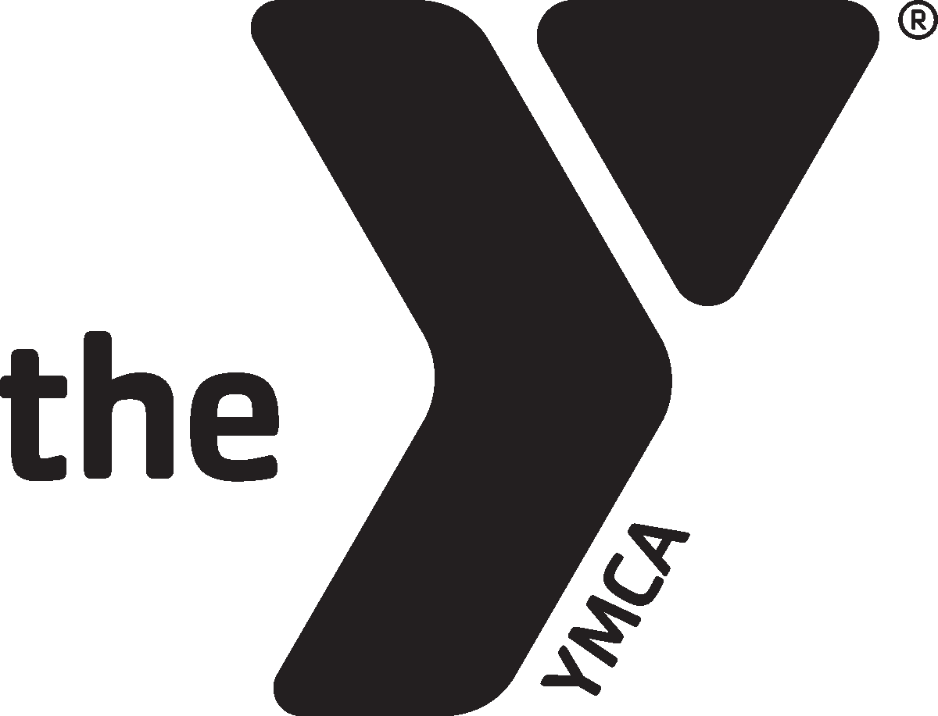

Indiana Alliance of YMCAs and YMCA Professional Network’s
2020 Staff Program Rally
April 23, 2020 | 10 am to 4 pm

AGENDA

9 am Registration Opens, Breakfast

10 am Welcome, Opening Session

11:15 am Workshops, Round 1

12:15 pm LUNCH

1 pm General Session

2 pm Workshops, Round 2

3 pm Awards, Closing Session

3:30 pm Peer Networks

4 pm Event ends

